- Use Figma to create an interactive diagram illustrating the components of a basic
cellular system.

DESIGN BY FIGMA :

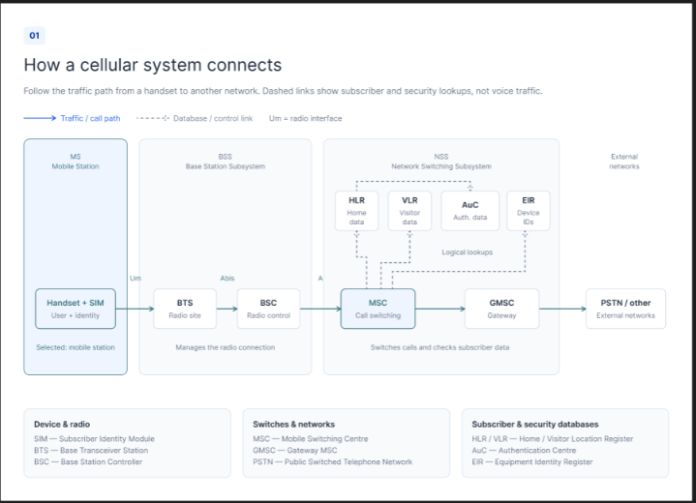

- Design a user interface prototype for a mobile station using Figma, considering
connectivity and convenience.

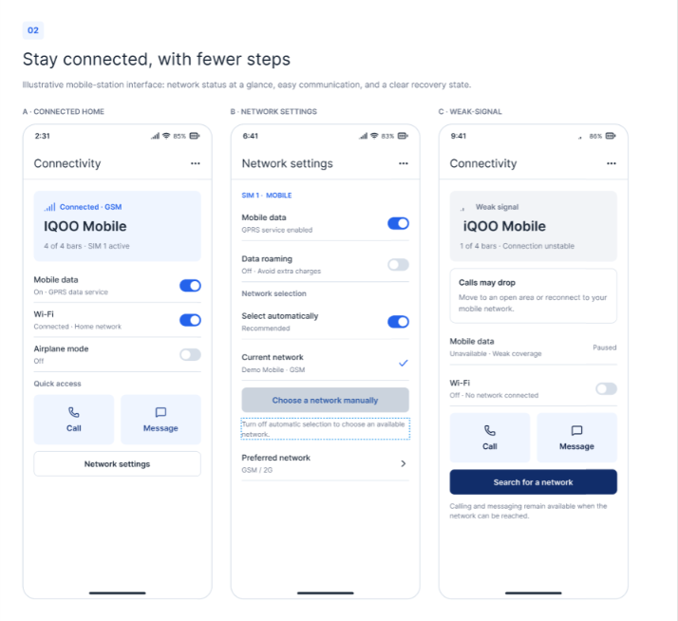

3.Develop a flowchart in Figma depicting the operation of a Network Switching
Subsystem in a mobile cellular system.

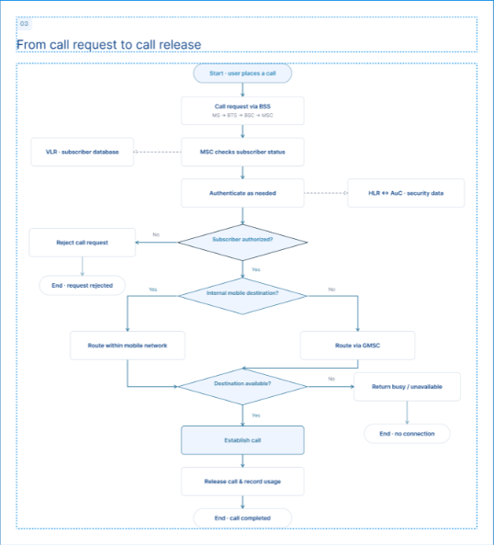

4.Create a visual representation in Figma highlighting the key elements of mobile
network protocol stacks.
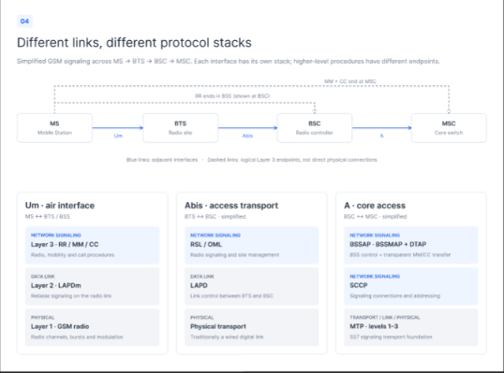

5. Design a wireframe for a mobile application that incorporates localization features
using Figma


